

|  |  |
| --- | --- |
| **Subject** | **DS & A(Data Structure and Algorithms )** |
| **Topic** | **SQL (DataBase)** |
| **Submitted To** | **Mam**  **Rafia Shaikh** |
| **Submitted By** | **Amaar Hussnain Raza** |
| **Roll #** | **20SW015** |
| **Section** | **I** |
| **Batch** | **20-Batch** |
| **Department** | **Software Engineering** |

Task #1:

SELECT * FROM web-events

Task #2:

SELECT id,occurred_at,toal_amt_usd from web_events order by occurred_at asc limit 10;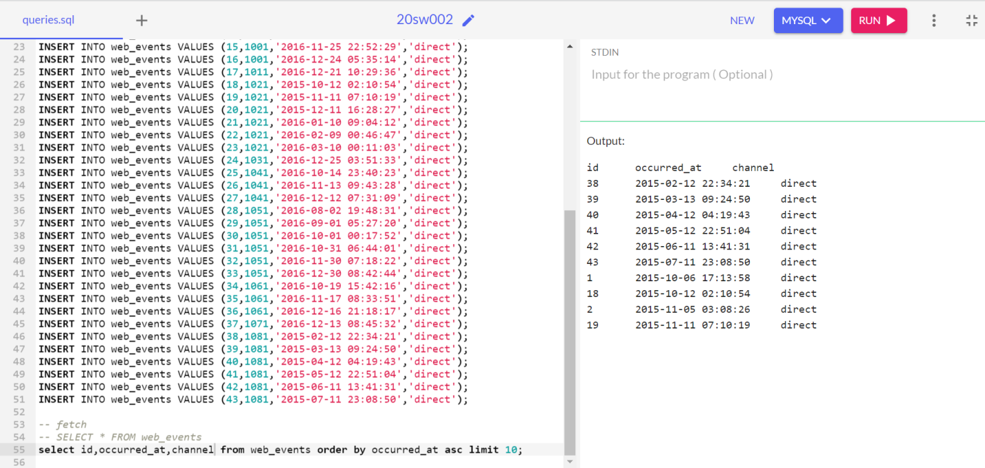

Task #3

select id,account_id,channel from web_events order by total_amt_usd desc limit 5;

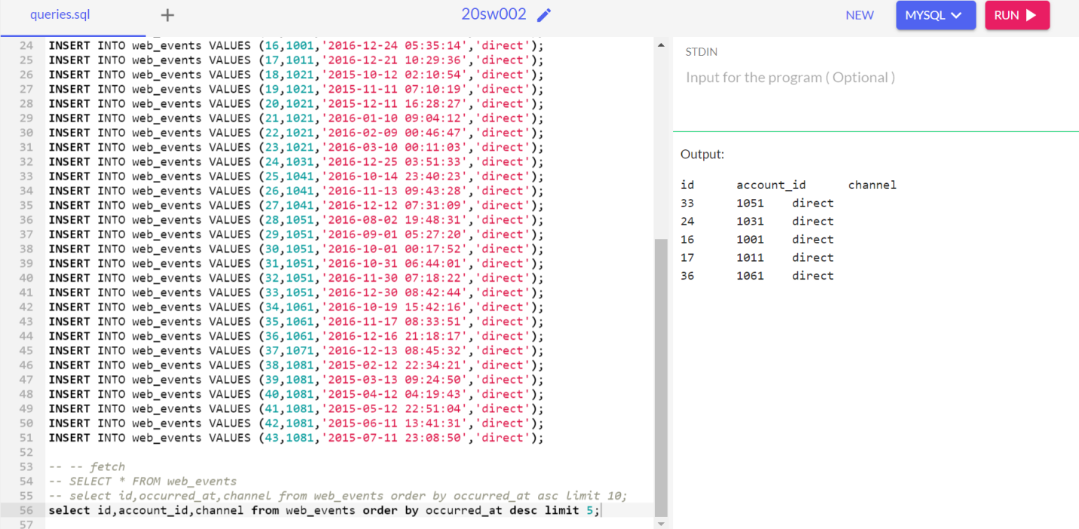

Task#4

select id,account_id,total_amt_usd from orders order by total desc limit 20;